# 2. Data Reduction, Tile Matching

## Overview

The algorithm to match tiles from the base image to the tile images in the database is described in broad steps directly below, and in more detail following this general description.

1. For each image in the Tile database:
   1. Initialize as Tile object with image path and title as parameters
   2. Analyze the image
      1. Load as a Numpy array with OpenCV2 for analysis purposes
      2. Shrink to suitable tile width (30) and crop squarely
      3. Save new height and width
      4. Calculate its color histogram and grayscale histogram
   3. Prepare the image for display
      1. Load with PIL format for easily pasting into mosaic later
      2. Resize to desired display tile width (150) and crop squarely
   4. *Optional:*
      1. Visualize the histogram as a bar chart and save to disk
      2. Find list of most dominant colors in the tile image and later in main save a dictionary where key is color and value is list of tiles with that dominant color
   5. Add new Tile object to a dictionary in main where its key is its title
2. For the Base image:
   1. Initialize as Base object by passing in image path and title as parameters
   2. Analyze the image
      1. Load as Numpy array with OpenCV2
      2. Resize to desired width (tile width of 30, multiplied by the desired number of columns in mosaic)
      3. Save new height and width
      4. Calculate color histogram and grayscale for every tile-sized (30 * 30) quadrant and append to “row list”, then append each “row list” to histograms list
      5. *Optional*: Find list of most dominant colors in the tile image
      6. Save number of rows and columns (where their product is the number of tiles needed to compose the image)
   3. Return Base object to main
3. For each quadrant histogram in the Base image:
   1. *Optional*: Dominant operation: Find best match by dominant color
   2. Expensive operation: Find “best match” by comparing quadrant histogram to *every single histogram* in the tile library, and using the tile with the least distance by L1 norm
   3. History operation: If this quadrant histogram has the same histogram as a previous quadrant, reuse the same “best match” tile

Bin Size

The chosen bin size for similarity.py are as follows:

COL_RANGE = 256

BINS = 4

gBINS = BINS*BINS *# need more bins for grayscale since there's only one axis*

BIN_SIZE = int(COL_RANGE/BINS)

gBIN_SIZE = int(COL_RANGE/gBINS)

DOM_COL_THRESH = 0.1

**Number of Color Bins: 4**

Because there are 256 RGB possible values in each color pixel, giving each color value a separate bin would make generating a histogram unfeasible because that would be accounting for ~16 million bins! Not to mention, there would certainly be a scarcity of data for each bin. Therefore, it was critical to determine a good size for clustering color values that would still capture the color distribution of an image histogram within decent runtime. As can be expected, we weres inclined toward testing values to the power of 2. While it is true that the color histograms generated with 8 and 16 bins had a wider and more diverse array of color bars compared to the histogram visuals (on the following page), we found out that we got very comparable results for best matching images and recognizable mosaics, where we chose 4, 8, or 16 bins for color. Therefore, we decided 4 was good enough, and fast enough. There were still 4*4*4 = 64 possible bins for the RGB values to go.

**Number of Gray Bins: 16**

Because there is only one axis for grayscale, we needed a greater range of

Color Histogram

Grayscale Histograms

Dominant Color

L1 Norm

Processing the Tiles

Processing the Base Image

Matching Tile Images

Expensive method

History method

Dominant color method

* Discuss different techniques: different aesthetic effects, different performance characteristics (i.e. took different amount of time to create the photomontage)
  + Also discuss what “kind” of images tend to do better with our method compared to others
* Limiting color bins / shades of gray (if we do grayscale)

So far tried:

* Expensive method, brute force (compare quadrant to every single tile in the database)
  + Problem is if we only pick the best tile each time, it’s expensive O(N*M) where N is the number of tiles in the database and M is the number of quadrants in the source image, also we’re using the extreme colors, so we have to search through this huge database and only use 90% of the images!
* History method (if quadrant has same histogram as earlier one, then reuse that closest tile)
* Dominant color method (find dominant colors of tiles, and organize them in a dictionary where the key is a color code, and the value is a list of tiles which have that as color as a dominant color … then find quadrants)

Discuss:

A decent report template: http://web.colby.edu/danelson/cs365-computer-vision/mosaic/

Downloading Images

Evaluation

* User studies
* Check how many tiles we actually use and try to figure out what images work well with what kinda datbases
* Can we write a method that can see how well an image database would perform with a given base image?

TODO:

* Rename reduction.py and all its references to processing.py
* Make a mosaic of ourselves and our cats! ☺
* Diversify the expensive method (so not always repeating same tile)
* Can write a method to check how many different tiles appear in a collage, and take that as a ratio of total number from database, to see how many images we actually use
* If we don’t actually use all the images, then we don’t need to load PIL display images for all of them. we could add a “cached” property to each tile… if it’s cached, that means it has a tile.display image and you can just use it, else you can load a new image with PIL and then cache it
* If we can increase efficiency and diversification, we can use a bigger database
  + Instead of loading only first 500 images for our database, we could load more images, or load RANDOM images from the database, not just 1-500!
* Try grayscale method and see effects
  + One way we can do a fast algorithm is to sort all the tile images in the database based on their brightness, then we can select the right image to match the cell in the source image based on itsposition, i.e. if we need a full black image, grab ones at the front of the sorted list, if needing full white, grab one at the end, and so forth for everything to begin
  + CAN WE DO SOMETHING SIMILAR WITH COLOR?
  + If we do blacmk and white, we’ll find that they work best with relatively HIGH CONTRAST source images

float aveBrightness(PImage img) {

float result = 0;

for (int i = 0; i < img.pixels.length; i++) {

result += brightness(img.pixels[i]);

}

result /= img.pixels.length;

return result;

}

* For this color similarity, we definitely need to think of methods that doesn’t involve searching through all tile databases to meach each cell. So far tried to the history and dominant color method, but it would be great to extend this sorting technique of the grayscale method. If we could find a way to translate each color into a signle number in a way that is perceptually meaningful,w e could use the same sorting technique to find the closest available tile. For example, we could treat the tile images as RGB pixels and combine three of them in close proximity (and appropriate levels of color intensity) to produce the average color of any cell in the image.
* Try different ways to measure similarity of color between each cell and tile imager (see below)
  + for example we can find the mean intensity value of the image and store it along with the tile in the tile class

Another potential way to compare by color:

**def** _get_average(image):

*""" Return a tuple of the form (r, g, b). This tuple contains the*

*average red, green and blue values for an image.*

*'image' is an Image object. """*

num_pixels = image.size[0] * image.size[1]

histogram = image.histogram()

red, green, blue = 0.0, 0.0, 0.0

**for** i **in** range(256):

red += i * histogram[i]

green += i * histogram[i + 256]

blue += i * histogram[i + 512]

**return** (red / num_pixels, green / num_pixels, blue / num_pixels)

**def** _get_closest(draft, database):

*""" Return the closest entry to 'draft' from 'database'.*

*The closest entry is the image whose average color value is closest*

*to the average color value of draft.*

*'draft' in an Image object.*

*'database' is a picture database. """*

average = _get_average(draft)

distances = []

**for** (tile, (r, g, b)) **in** database.items():

distances.append((((r - average[0]) ** 2 +

(g - average[1]) ** 2 +

(b - average[2]) ** 2) ** 0.5, tile))

**return** min(distances)[1]

FUTURE IMPROVEMENTS:

* A user interface
* Use tile pictures that are conceptually related to the source image
  + Fix instagram zipper file not to grab images by user, but instead grab images by hash tags!
* Vary the size of the individual images in the grid
  + While the uniformity of the grid is nice for making the image as clear as possible, it would be compositionally more interesting and collage-like to have the sizes of the images vary more
  + Could try breaking up the rectangular shape of each of the source images and using masking
  + Using Laplacian or Canny edge dtection to detect edges of the picture
* Would have liked to play with Jigsaw method or explore Voronoi stippling. This is a technique for converting a grayscale image into a series of dogs of different weights to represent the darkness of each region in a natural way, much like stipped drawings created by hand
* Build the image bank from another collection of images, like your personal photo collection.
* Generate some exceptionally creative mosaics. For inspiration, check out the art of [Chris Jordan](http://www.chrisjordan.com/).
* Build a histogram of the number of tiles for each grayscale intensity. Rescale the intensity of images so that each grayscale level has several photos to choose from.
* Come up with a fast way of selecting image tiles that does not require comparing each pixel to each tile's mean intensity.
* To create mosaics of larger images without having to rescale first, replace every NxN image patch with a tile, where N is chosen based on the target image size to create a reasonably-sized mosaic.
* Last semester, a large image of Bruce Maxwell hung in the CS department lobby; in this image different grayscale values where created with black dots of varying size. Modify your program so that you can create large printouts of your mosaics.

Finding dominant colors

Threshold for dominant colors: 0.07

Should we look at k-means clustering?

http://www.pyimagesearch.com/2014/05/26/opencv-python-k-means-color-clustering/

|  |  |  |  |
| --- | --- | --- | --- |
| https://lh3.googleusercontent.com/Qt3uXeZeiWBEKBeMFj3mRCk0a1Ut1bdeS9nD03M9zex6PuYvII7HtQ4nRayWCSIHONVavwSyA4VowqUC5be3vUCWD54ieGyggT0YkfU1QTnJnogJKgPsJ8WYBARXeGnhCyjHgEg | https://lh6.googleusercontent.com/U7ZInisGPns_84WXU-I3D6dYvjOw3_q3VDk-9BxMwML2oiWGwYQaFI4iuWYNmZ515YvJBY_GwOyPB8yIcDxkeega6UMnCkX7TvxcJOIQ8pkLtBE-SEO8-wg_wX96IFPdFnujoQM | https://lh6.googleusercontent.com/kS4igZBMQakLGi03M6YqvCU6gfMGDxHY0K5d3Ys6xgH9PDmYEdL0TZjiQQd6EGedS0Rw0myuU01BDC7sjDW_seMAlJ8LrCytwvZ9-s3LLu--oDmbC8TGc2p_1ciVVK8j3mgXNFQ | https://lh3.googleusercontent.com/WGHpjViaCJq_v5v4_Z3EHA4Boj6zRJM_QebxU8Zl9b3B2szaFyyxBAuPrThqBUnTikpKuqR_qMSN-rKWkw3w4Yzw0CqRTCLkIP_udDOM8YQ5d8dOln6hOIBRsCza9PpvUEPPvRs |
| https://lh5.googleusercontent.com/mgqkAF4JP_lzutSK1-t-aAzKFVuKrUkhT-iBIpgkHE088mXvWe_z5SZnIHpcJ_Ozkc789ATxsyDmMY9gSf5IIm9hSZukPbMDN8faA8gFA1yvRM3WtxugB-Pfvn4x7i1_vOEu9Rc  [0.093, 0.071, 0.067, 0.058, 0.053, 0.049, 0.049, 0.04, 0.036, 0.036, 0.036, 0.036, 0.031, 0.031, 0.031, 0.027, 0.027, 0.027, 0.022, 0.022, 0.022, 0.018, 0.013, 0.013, 0.013, 0.009, 0.009, 0.009, 0.009, 0.004, 0.004, 0.004, 0.004, 0.004, 0.004, 0.004, 0.004, 0.004, 0.004] | https://lh3.googleusercontent.com/_ePG6l-FysqJtxtaHN0WfCsuLpKwAHkkmQrwZMT7tuShb0YuINKlDHDgDxNOTcfembVxokYkOrbv0ApgO0Izacp2ORtztzMp93kfUDitwPtvm8dfE_GXNMbf3-cdiHzWvP1i-SE  [0.124, 0.098, 0.071, 0.058, 0.044, 0.04, 0.036, 0.031, 0.031, 0.027, 0.027, 0.027, 0.022, 0.022, 0.018, 0.018, 0.018, 0.018, 0.013, 0.013, 0.013, 0.013, 0.009, 0.009, 0.009, 0.009, 0.009, 0.009, 0.009, 0.009, 0.009, 0.009, 0.009, 0.009, 0.009, 0.009, 0.009, 0.009, 0.004, 0.004, 0.004, 0.004, 0.004, 0.004, 0.004, 0.004, 0.004, 0.004, 0.004, 0.004, 0.004, 0.004, 0.004, 0.004, 0.004] | https://lh4.googleusercontent.com/s4a9B1UJLqB40htkwSMXb2beAysktUQ0ADDhILD_ET1hnlxUEct3fWfMs-FO1aIJGW6F0OZ-wIPLJMyVMRdhgsNvgOrX5H92UnMDpT4HCxeVbMOoiOftKJap7eXIJWaScDDRfZ4  [0.316, 0.244, 0.102, 0.067, 0.067, 0.049, 0.031, 0.018, 0.018, 0.018, 0.013, 0.009, 0.009, 0.004, 0.004, 0.004, 0.004, 0.004, 0.004, 0.004, 0.004, 0.004] | https://lh4.googleusercontent.com/kUVqMCBkW9D9r_pnldet7Guko8J2UiQ8vwxNKBqH9jGhaegVip6S5r0GJXFNBjw87OsYX0ze3-Gb8i4I5J7-dbt41I1SqWxF56k58cAsTL7LOvfdF4Rp7tj7BT3jqPVE2IapT4w  [0.089, 0.08, 0.053, 0.053, 0.049, 0.044, 0.036, 0.036, 0.031, 0.027, 0.027, 0.022, 0.022, 0.022, 0.022, 0.018, 0.018, 0.018, 0.018, 0.018, 0.018, 0.013, 0.013, 0.013, 0.013, 0.013, 0.013, 0.013, 0.013, 0.013, 0.009, 0.009, 0.009, 0.009, 0.009, 0.009, 0.009, 0.009, 0.009, 0.009, 0.009, 0.004, 0.004, 0.004, 0.004, 0.004, 0.004, 0.004, 0.004, 0.004, 0.004, 0.004, 0.004, 0.004, 0.004]  Fails over here |

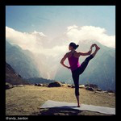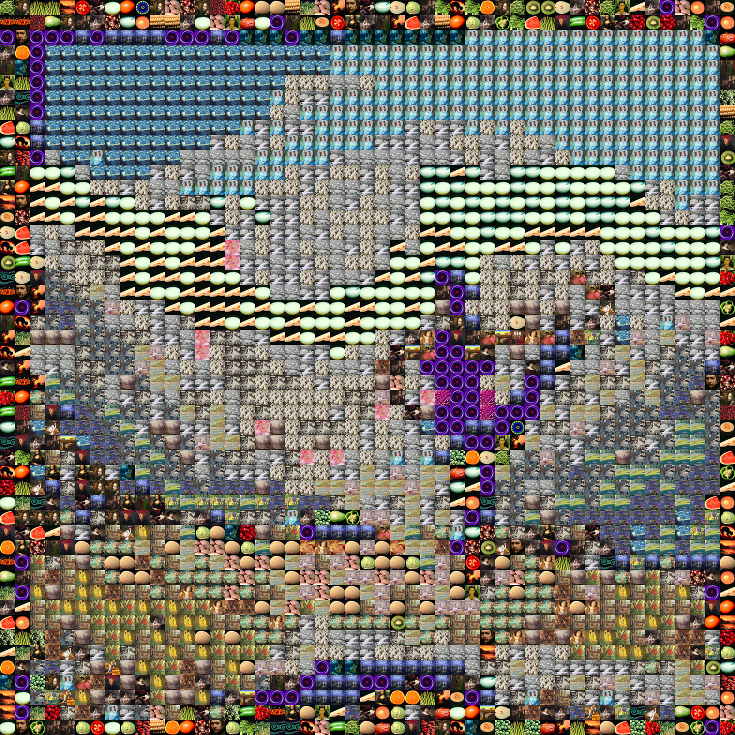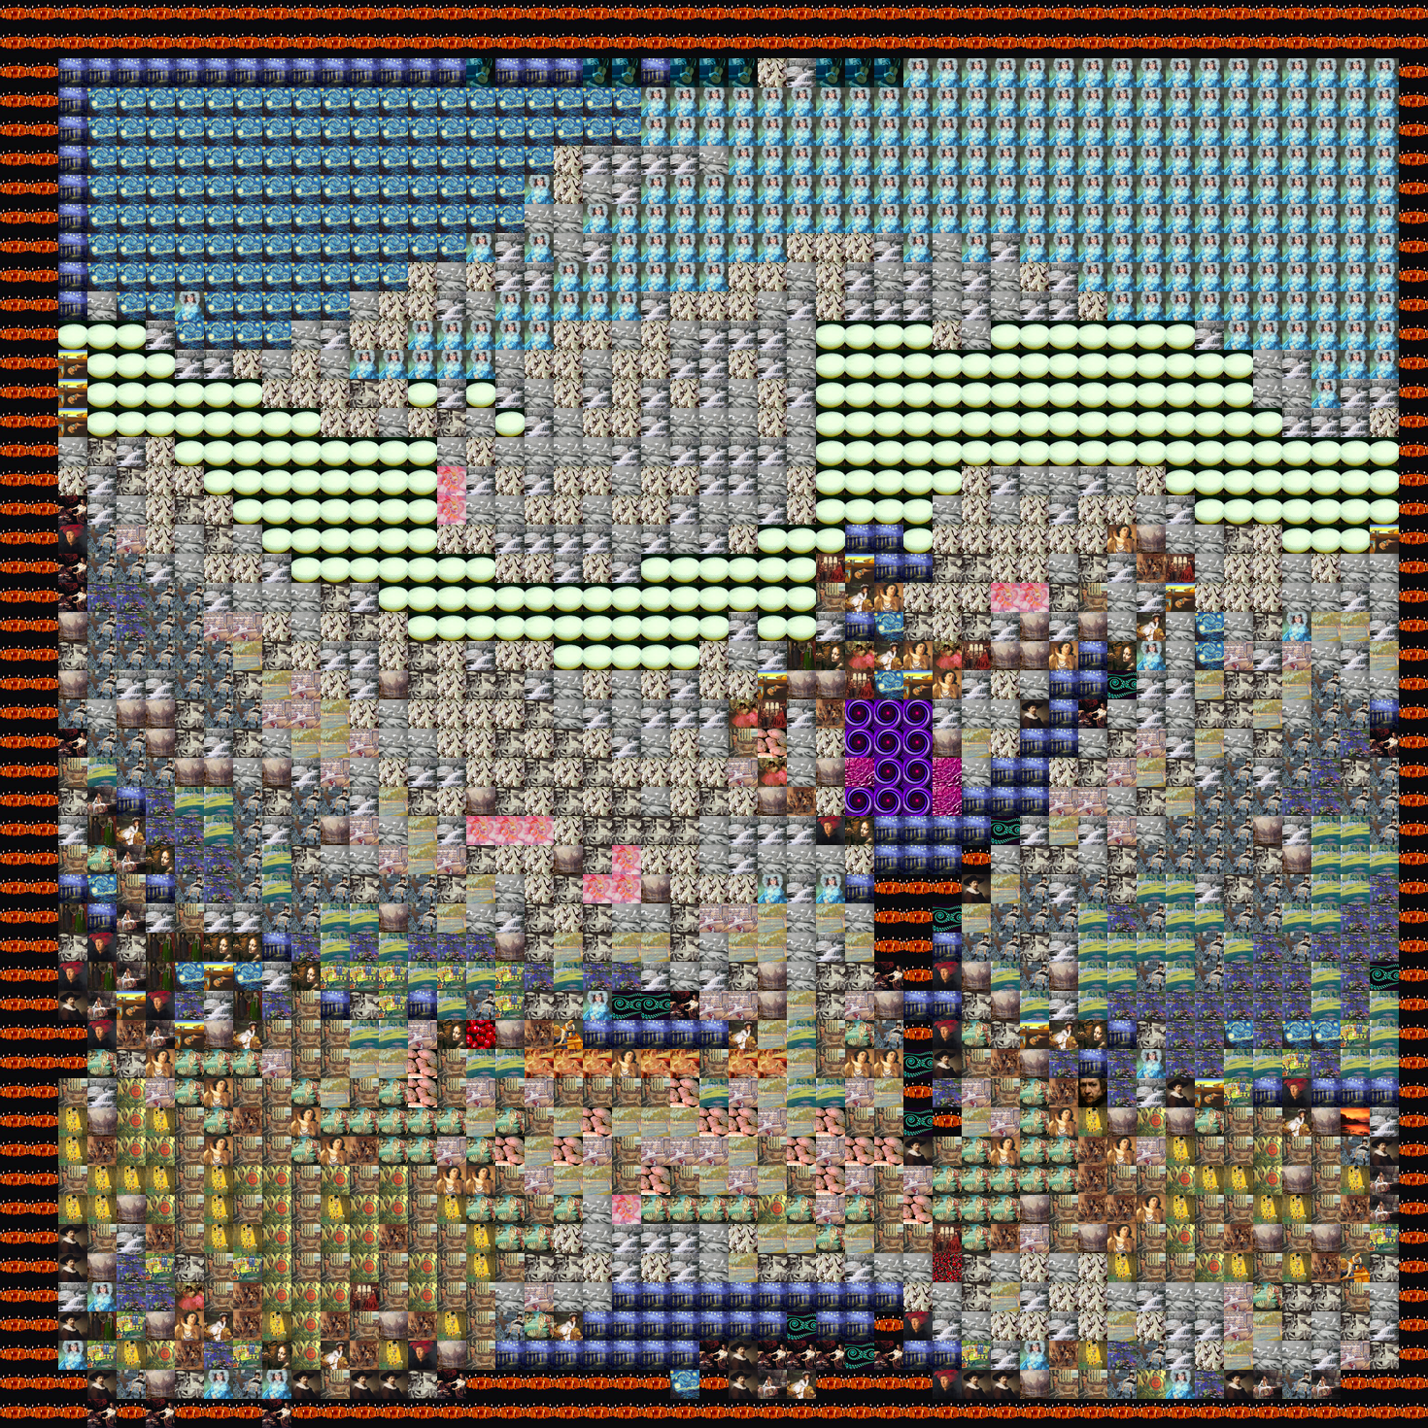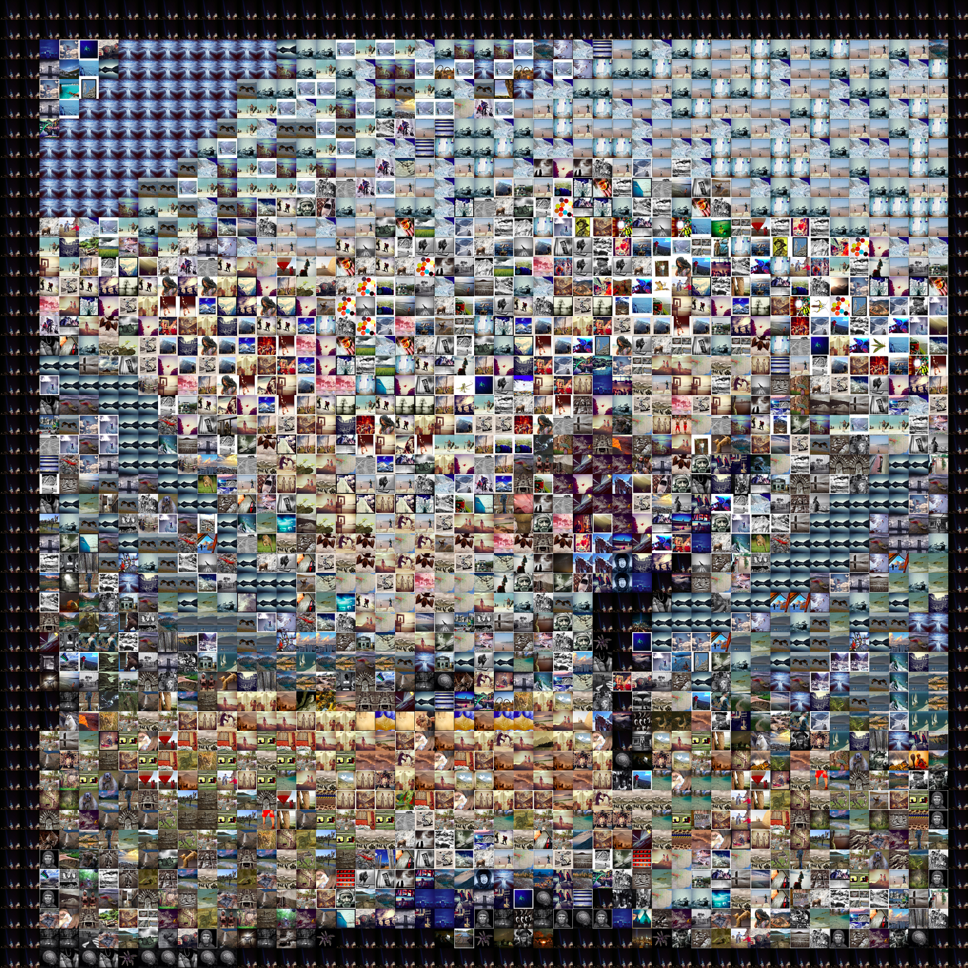

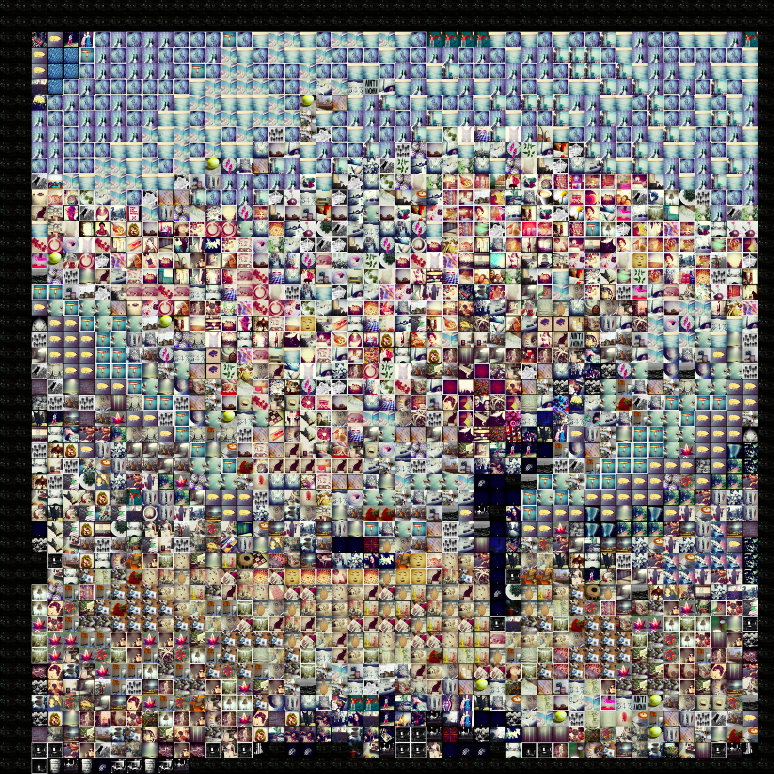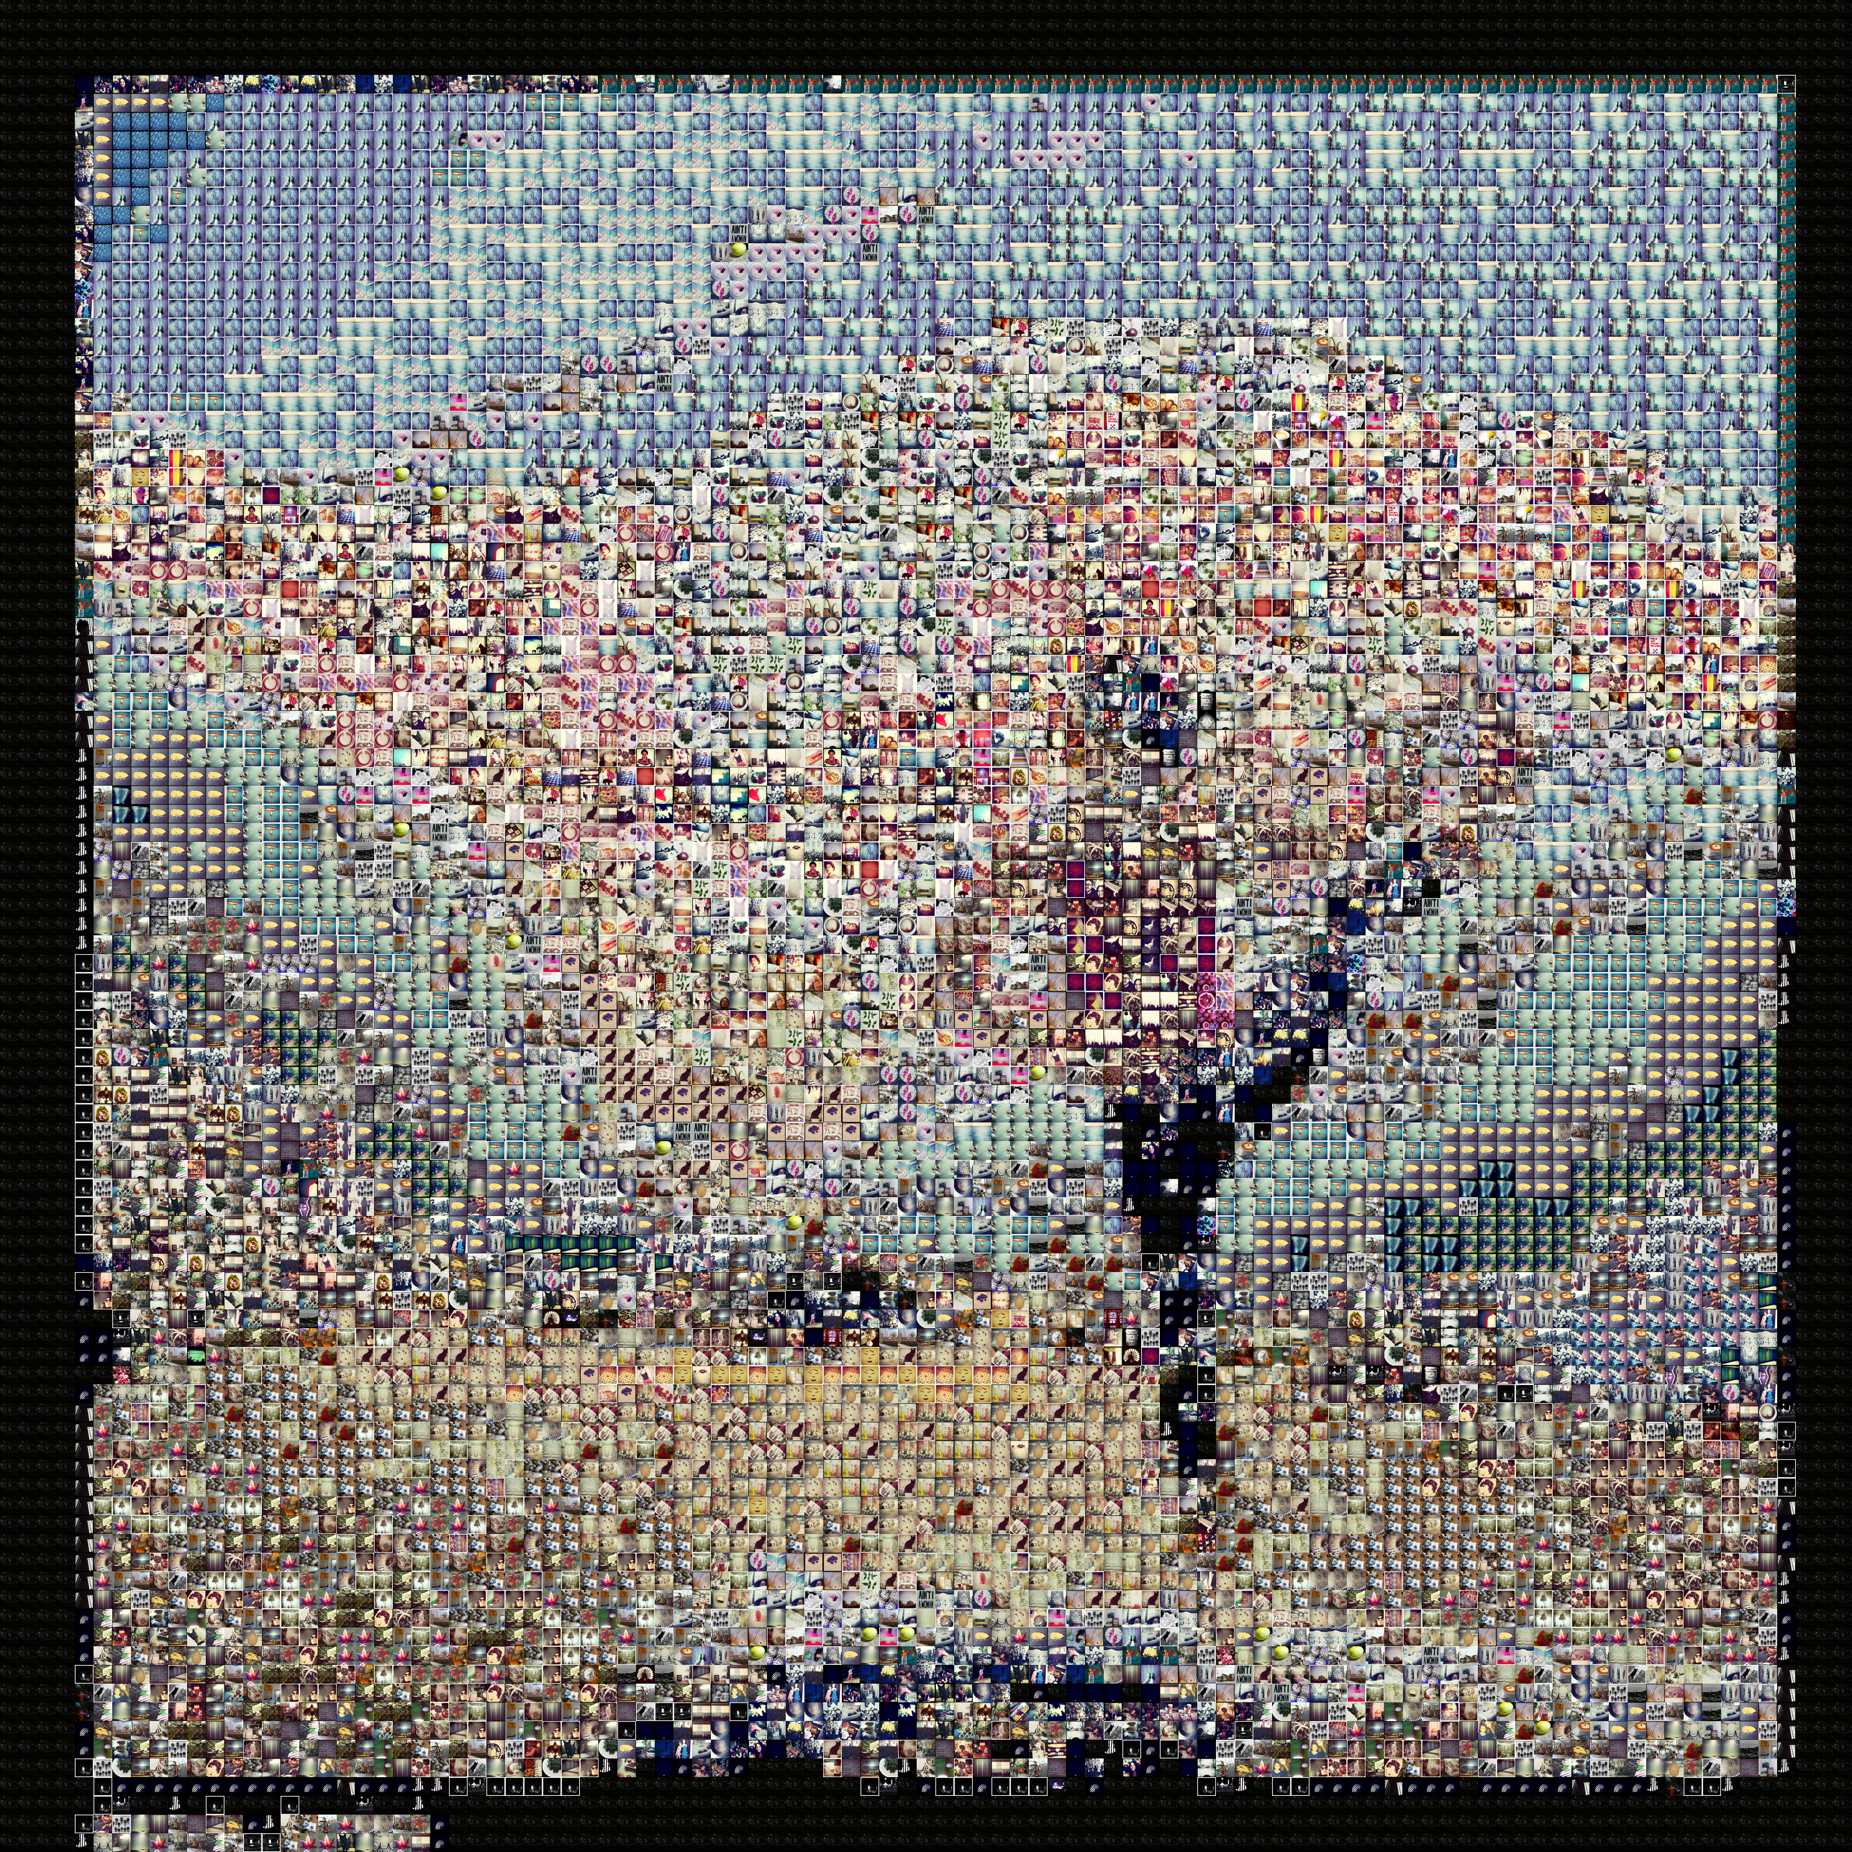 100 columns

second one has a higher percentage requirement for image to be considered best match for black (only if bin-downsized rgb is 0,0,0)

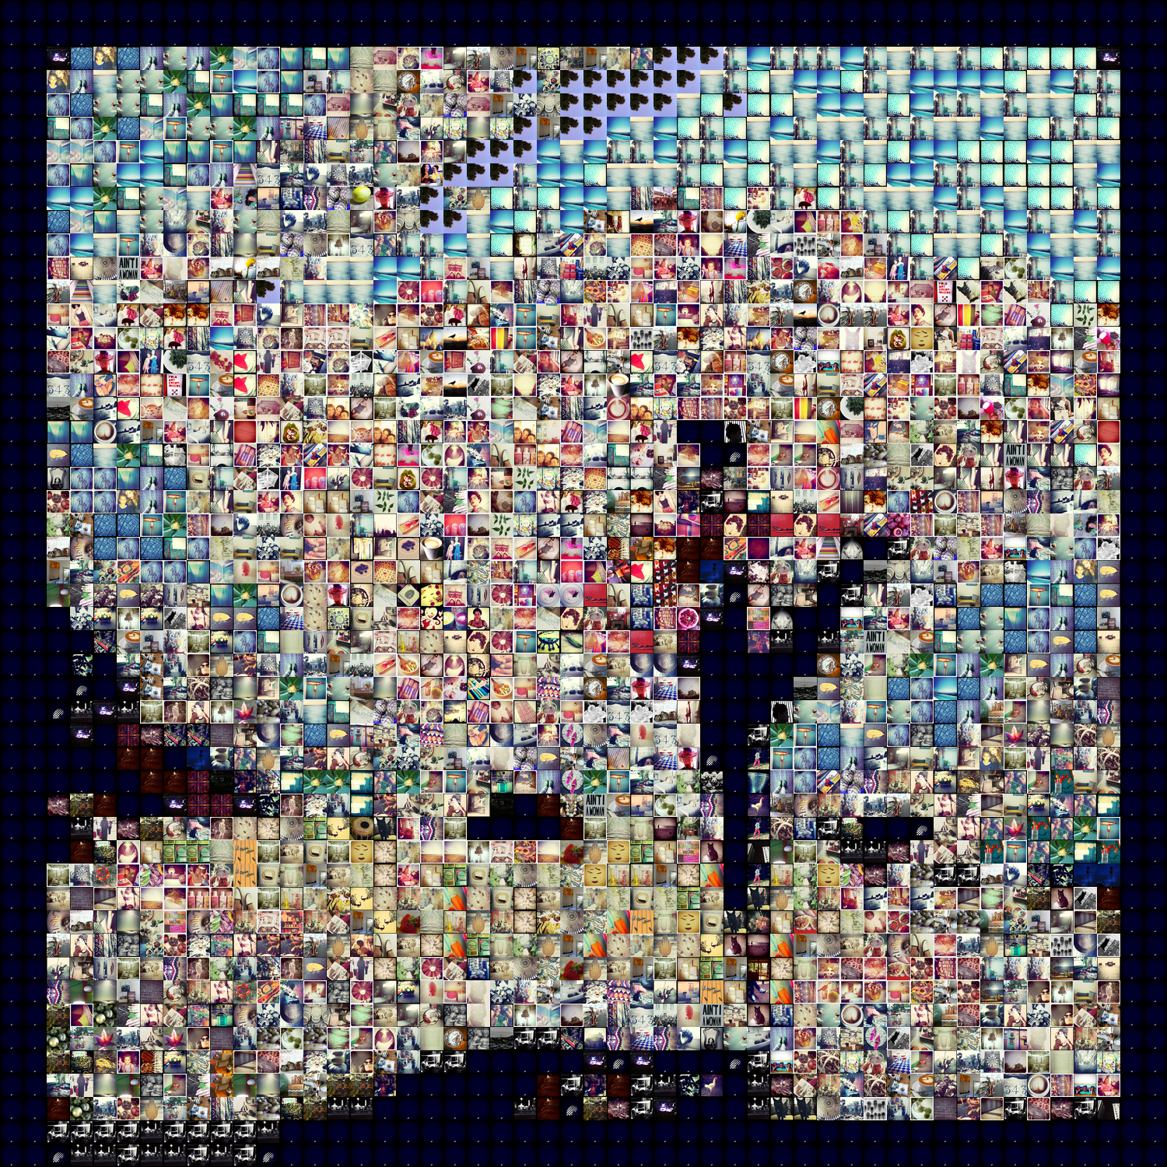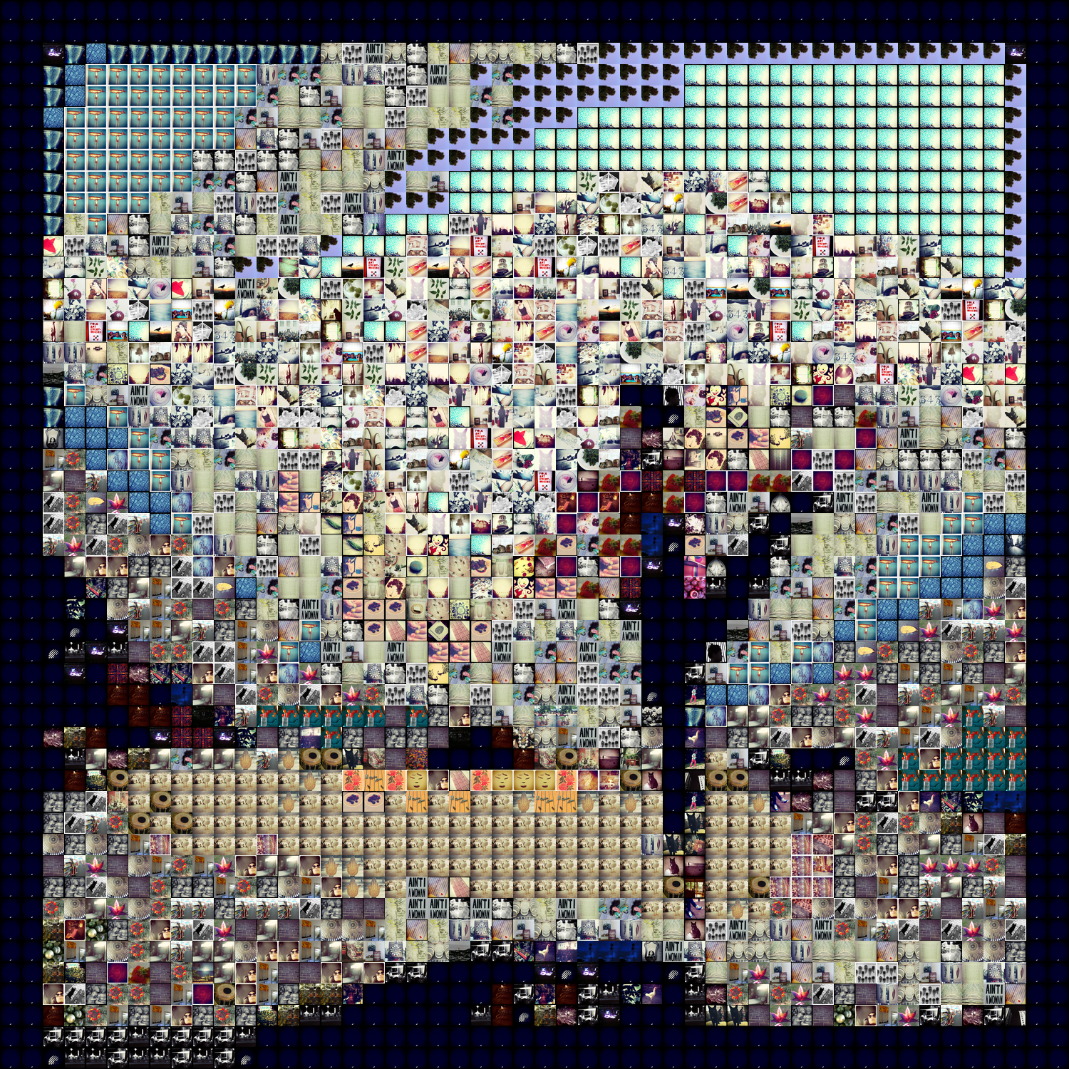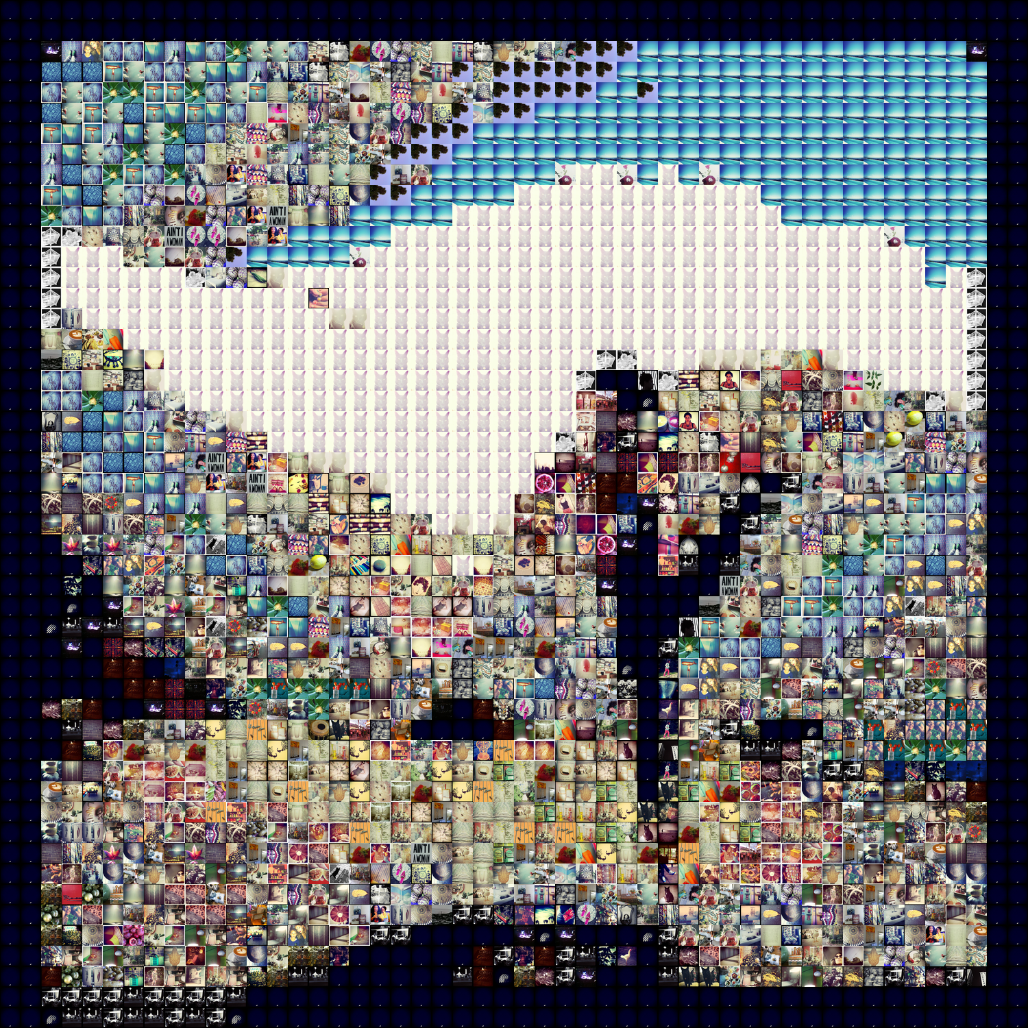

4 bins instead of 8 when min percentage a pixel must have to be considered dominant color is 0.3 instead of 0.1

dealing differently with black and white

Taking out measures of color dominance

Expensive operations: 588 of 2500 : 0.2352

Dominant operations: 0 of 2500 : 0.0

History operations: 1912 of 2500 : 0.7648

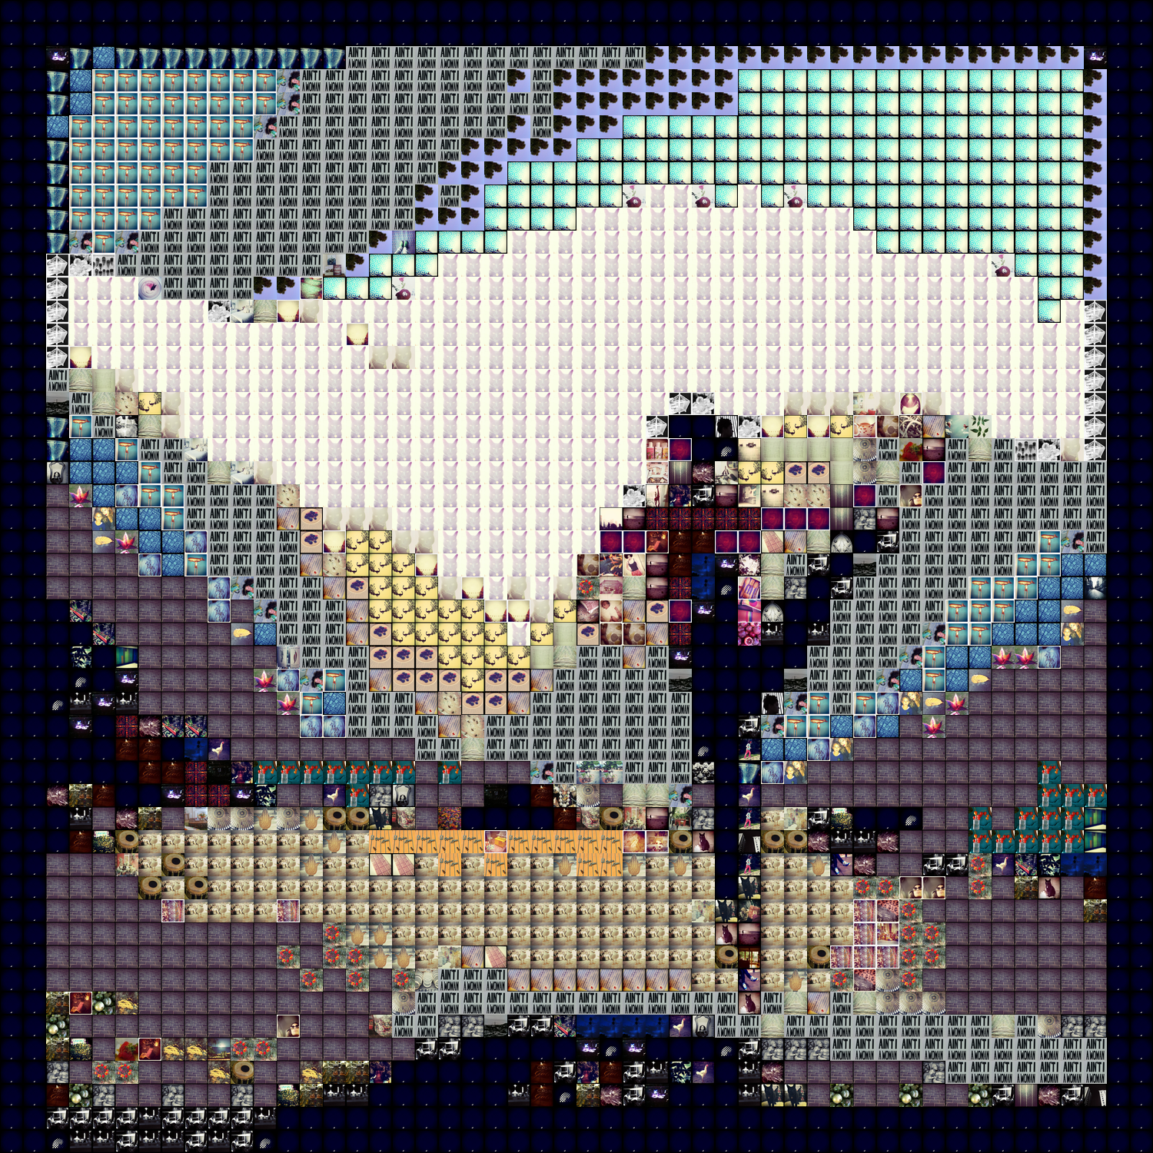 this method doesn’t use dominant colors, only best matches

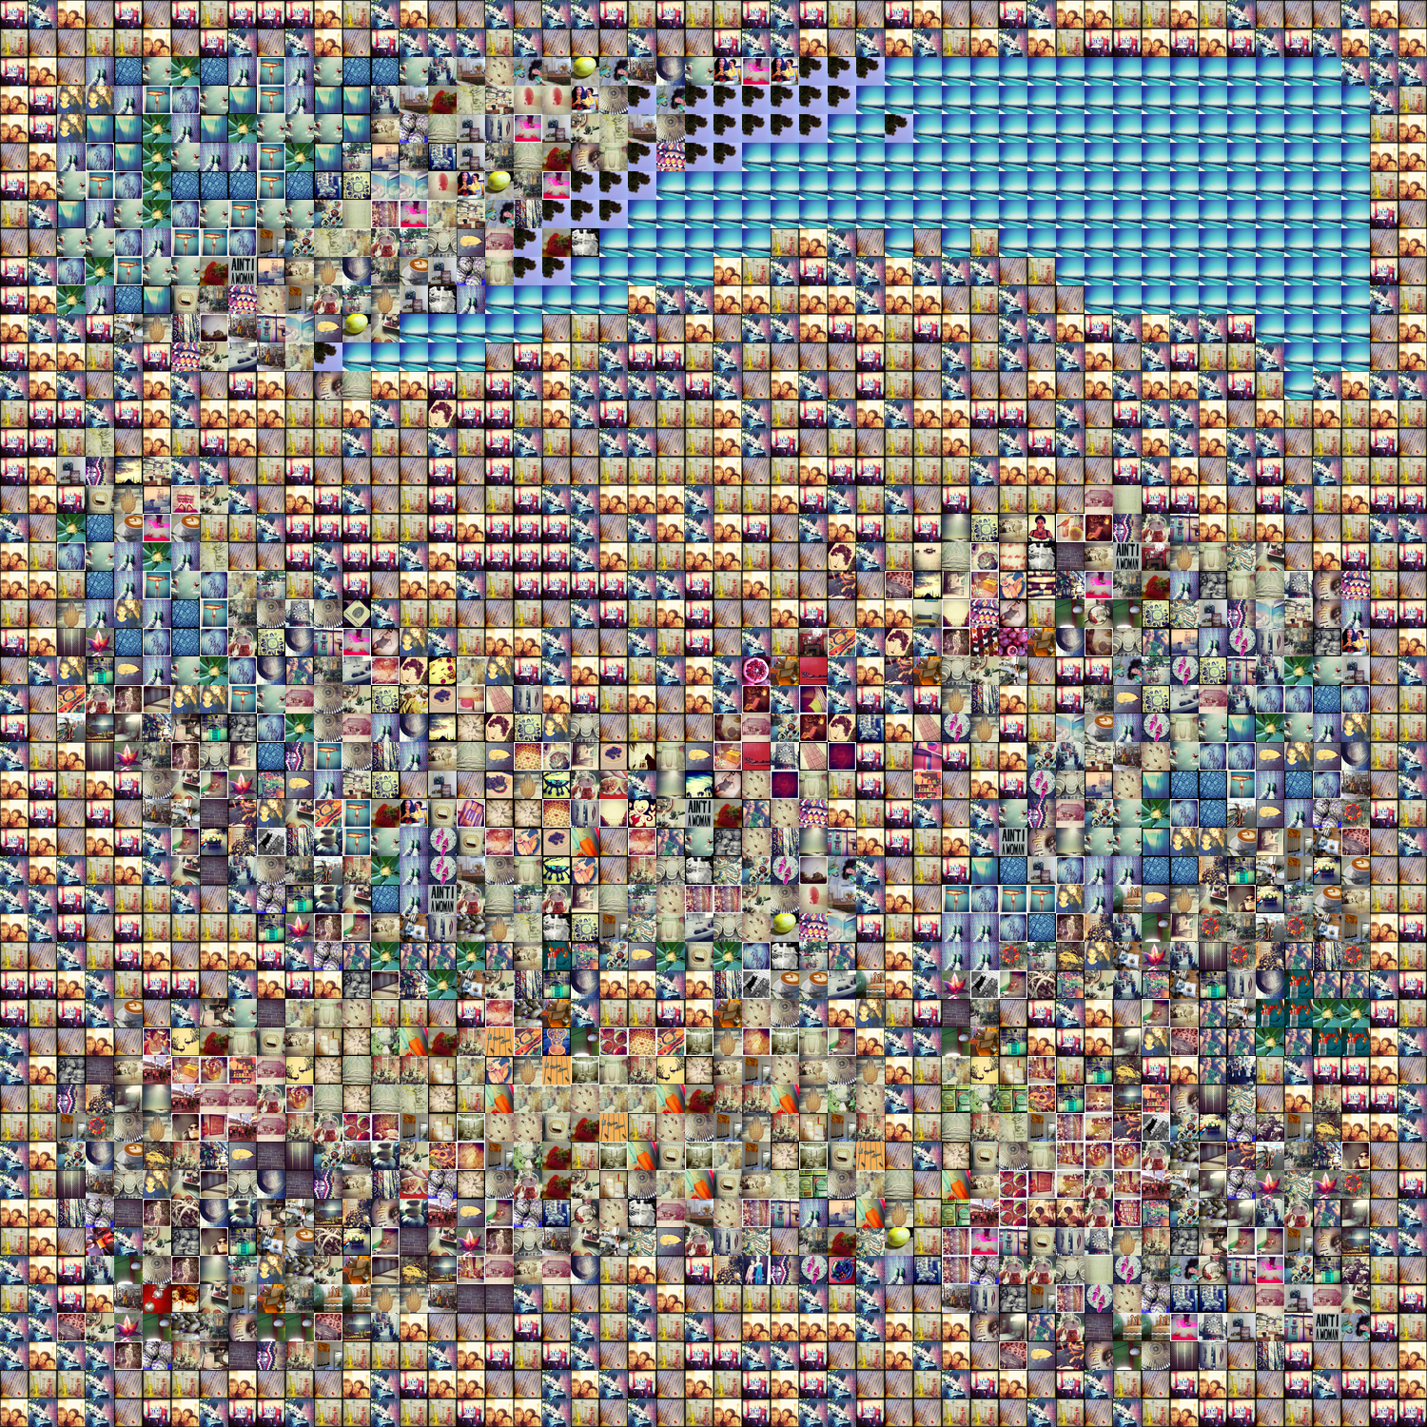 <- something very broken here when I try to save the top 5 closest tiles instead of just 1 best match

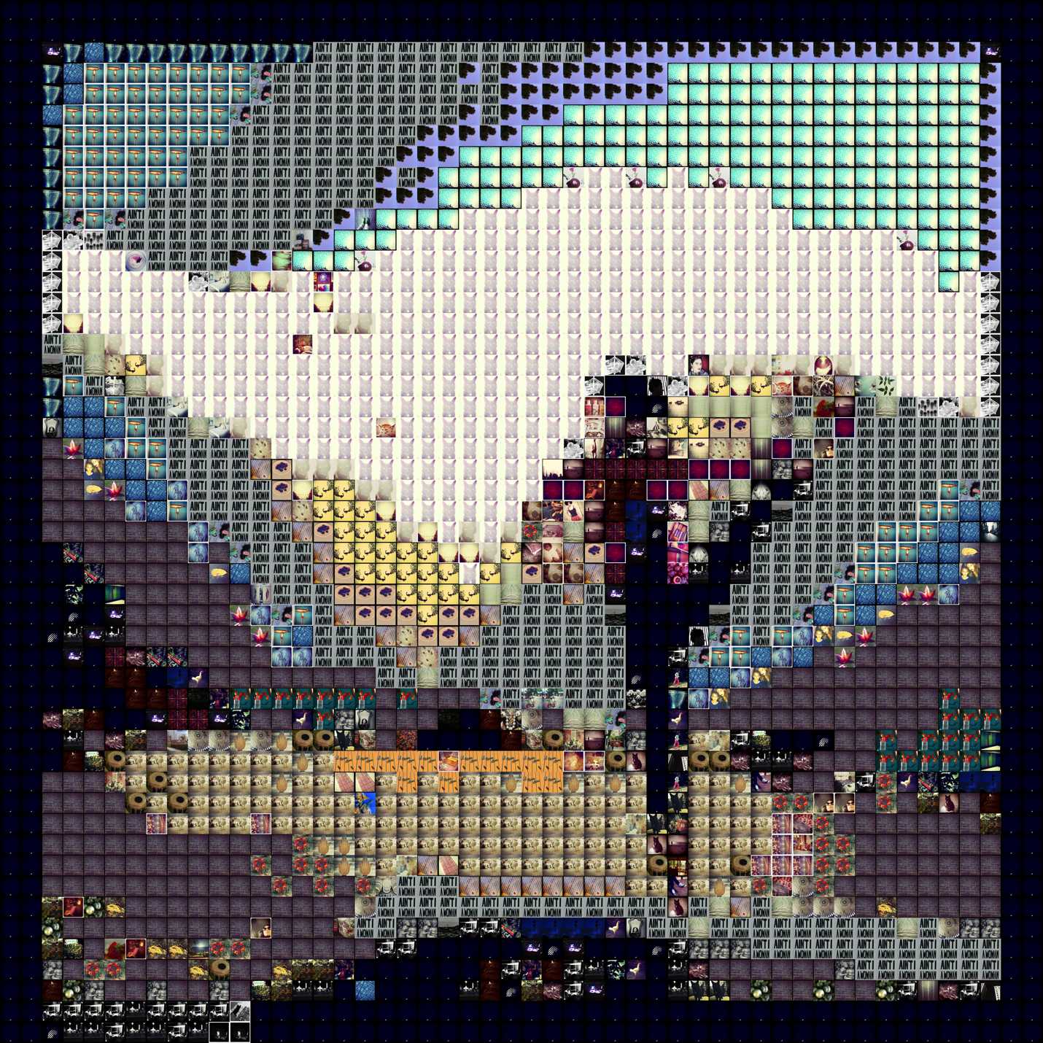

Expensive operations: 587 of 2500 : 0.2348

Dominant operations: 35 of 2500 : 0.014

History operations: 1878 of 2500 : 0.7512

Percent of possible tiles used: 0.236, 118 out 500 images from tile library used

Expensive operations: 588 of 2500 : 0.2352

Dominant operations: 0 of 2500 : 0.0

History operations: 1912 of 2500 : 0.7648

Photomosaic: digital images composed of many smaller images

A photomosaic is created by replacing each pixel in some target image with a tile from an image bank. Each tile is selected to have properties similar to the pixel it replaces, such that when the assembled mosaic is displayed at a coarse resolution it resembles the target image. Zooming in to finer resolutions reveals the individual tile images.

Expensive operations: 588 of 2500 : 0.2352

Dominant operations: 0 of 2500 : 0.0

History operations: 1912 of 2500 : 0.7648

# 1. Domain Engineering and Introduction

|  |
| --- |
| from __future__ import division |
| import sys, os |
| import random |
| import cv2 |
| import numpy as np |
| import tile as T |
| import base as B |
| import similarity as S |
| from PIL import Image |
|  |
| ALPHA = 1.0 |
|  |
| def entitle(impath, path, format): |
| start = len(path)+1 |
| end = len(format)*-1 |
| title = impath[start:end] |
| return title |
|  |
| def main(): |
| # Check if user has provided a base image and tile library |
| if len(sys.argv) < 2: |
| sys.exit("Usage: python main.py base-image-path tile-directory-path tile-format\n \ |
| Example: python main.py A3.png _extras/jb .png") |
|  |
| # Parse command line args |
| base_path = sys.argv[1] |
| format = sys.argv[1][-4:] |
| tile_path = sys.argv[2] |
|  |
| if len(sys.argv) is 4: |
| format = sys.argv[3] |
|  |
| # Read tile library images first |
| print "Analyzing tile library images..." |
| if os.path.exists(base_path) and os.path.exists(tile_path): |
| imfilelist=[os.path.join(tile_path,f) for f in os.listdir(tile_path) if f.endswith(format)] |
| if len(imfilelist) < 1: # number of tile images |
| sys.exit ("Need to specify a path containing " + format + " files") |
| tiles = {} # init dictionary of tile objects |
| dominants = {} # init dictionary of list of tiles by dominant color |
| num_images = len(imfilelist) |
| if num_images > 500: |
| num_images = 500 # only look up first 500 images |
| for i in xrange(num_images): |
| impath = imfilelist[i] |
| # print(impath) |
| if ( (i+1)%50 == 0 or i == num_images-1 ): |
| print i+1, "out of", num_images, "images" |
| imtitle = entitle(impath, tile_path, format) |
| tile = T.Tile(impath, imtitle) |
| tiles[imtitle] = tile |
| """for color in tile.dominants: |
| if color in dominants: |
| dominants[color].append(tile) |
| else: |
| dominants[color] = [tile]""" |
| else: |
| sys.exit("The path name does not exist") |
|  |
| print "" |
|  |
| # Next, analyze base image |
| print "Analyzing base image..." |
| base = B.Base(base_path) |
|  |
| # Find best tiles to compose base image |
| print "" |
| print "Generating mosaic..." |
| the_chosen = [] |
| history = {} # store histogram-best tile matches |
| count = base.rows * base.cols |
| dom_count = 0 |
| history_count = 0 |
| expensive_count = 0 |
|  |
| for i in xrange(base.rows): |
| hist_row = base.histograms[i] |
| grayscales = base.grayscales[i] |
| #dom_row = base.dominants[i] |
| the_row = [] |
| for j in xrange(base.cols): |
| skip = False |
| histogram = hist_row[j] |
| graygram = grayscales[j] |
| """ Optional: use dominant colors method |
| for dom in dom_row[j]: |
| if dom in dominants: |
| closest_tile = random.choice(dominants[dom]) |
| skip = True |
| dom_count += 1 |
| break""" |
| if (skip == False): |
| closest = 100 |
| if str(histogram) in history: |
| closest_tile = history[str(histogram)] |
| # This constant-time lookup saves a lot of calculations |
| history_count += 1 |
| else: |
| for key in tiles: |
| tile = tiles[key] |
| dcolor = S.l1_color_norm(histogram, tile.histogram) |
| dgray = S.l1_gray_norm(graygram, tile.gray) |
| distance = ALPHA*dcolor + (1-ALPHA)*dgray |
| if (distance < closest): |
| closest = distance |
| closest_tile = tile |
| # print closest_tile |
| history[str(histogram)] = closest_tile |
| expensive_count += 1 |
| the_row.append(closest_tile.title) |
| the_chosen.append(the_row) |
| # print the_row |
| print "%d out of %d rows" %(len(the_chosen), base.rows) |
|  |
| # Generate mosaic |
| print "" |
| size = tile.display.size # any tile will have the same size |
| if ALPHA == 0: #grayscale mosaic |
| print "Your GRAYSCALE MOSAIC will be done soon." |
| mosaic = Image.new('L', (base.cols*size[0], base.rows*size[1])) |
| else: |
| print "Your COLORFUL MOSAIC will be done soon." |
| mosaic = Image.new('RGBA', (base.cols*size[0], base.rows*size[1])) |
| rowcount = 0 |
| # print "row: " + str(rowcount) |
| for row in xrange(base.rows): |
| colcount = 0 |
| # print "column: " + str(colcount) |
| for col in xrange(base.cols): |
| idx = the_chosen[row][col] |
| tile = tiles[idx] |
| img = tile.display |
| mosaic.paste(img, (colcount*size[0], rowcount*size[1])) |
| colcount += 1 |
| rowcount += 1 |
| mosaic.save("mosaic.png") |
|  |
| f = open('mosaic_keys.txt', 'w') |
| f.write(str(the_chosen)) |
|  |
| # Calculate percentage of database used and print stats |
| print "" |
| n = len(set([img for sublist in the_chosen for img in sublist])) |
| print "%f : %d out %d images from tile library used" %(round((float(n)/len(tiles)), 3), n, len(tiles)) |
| print "" |
| print "Expensive operations:", expensive_count, "of", count, ":", expensive_count/count |
| print "Dominant operations:", dom_count, "of", count, ":", dom_count/count |
| print "History operations:", history_count, "of", count, ":", history_count/count |
|  |
| if __name__ == "__main__": main() |
| import cv2 |
| import reduction as R |
| import similarity as S |
| from PIL import Image |
|  |
| TILE_WIDTH = 30 |
| DISPLAY_WIDTH = 150 |
|  |
| class Tile(): |
| def __init__(self, path, title): |
| """Open in Numpy format for histogram analysis""" |
| self.path = path |
| self.title = title |
| size = (TILE_WIDTH, TILE_WIDTH) |
| self.image = cv2.imread(path, cv2.IMREAD_UNCHANGED) |
| self.image = R.crop_square(self.image, size) |
| self.height = len(self.image) |
| self.width = len(self.image[0]) |
| self.histogram, self.image, self.colors = S.color_histogram(self.image, self.title) |
| self.gray = S.grayscale_histogram(self.image, self.title) |
|  |
| """Open with PIL format for display purposes""" |
| self.display = Image.open(path) |
| self.display = R.resize_square(self.display, (DISPLAY_WIDTH, DISPLAY_WIDTH) ) |
| # Crop image to square (simply set size for last param if you want 30x30 tiles) |
| # (width, height) = self.display.size |
| # if (width < height): |
| # self.display = R.resize_square(self.display, (width, width) ) |
| # elif (height < width): |
| # self.display = R.resize_square(self.display, (height, height) ) |
| # self.display = R.fill(self.display, self.title) |
|  |
| """Additional options (extra runtime)""" |
| # Optional: generate bar chart to visualize histogram |
| # plot_path = S.plot_histogram(self.histogram, self.title, self.colors) |
|  |
| # Optional: find dominant colors |
| # self.dominants = S.dominant_colors(self.histogram, self.colors) |
| # self.dominants = S.kmeans_dominance(self.image) |
| # print self.dominants |

|  |
| --- |
| import cv2 |
| import reduction as R |
| import similarity as S |
|  |
| TILE_WIDTH = 30 |
| TILE_COLS = 50 |
|  |
| class Base(): |
| def __init__(self, path): |
| self.path = path |
| self.image = cv2.imread(path, cv2.IMREAD_UNCHANGED) |
| # Will actually discount second value |
| self.image = R.resize_by_w(self.image, TILE_WIDTH*TILE_COLS) |
| self.height = len(self.image) |
| self.width = len(self.image[0]) |
| self.histograms = [] |
| self.dominants = [] |
| self.grayscales = [] |
| # Equivalent to for(int j=0; j<self.height-TILE_WIDTH; j+=TILE_WIDTH) |
| # Advantage of this way is if self.width%TILE_WIDTH != 0 |
| for j in xrange(0, self.height, TILE_WIDTH): |
| hist_row = [] |
| # dom_row = [] |
| gray_row = [] |
| for i in xrange(0, self.width, TILE_WIDTH): |
| start_y = j |
| end_y = j + TILE_WIDTH |
| start_x = i |
| end_x = i + TILE_WIDTH |
| quadrant = R.crop(self.image, start_y, end_y, start_x, end_x) |
| title = "base" + str(end_x) + "-" + str(end_y) |
| histogram, quadrant, colors = S.color_histogram(quadrant, title) |
| grayscale = S.grayscale_histogram(quadrant, title) |
| # Optional, save histogram as bar graph; or record dominant colors |
| # plot_path = S.plot_histogram(histogram, title, colors) |
| # dominants = S.dominant_colors(histogram, colors) |
| # dominants = S.kmeans_dominance(self.image) |
| hist_row.append(histogram) |
| # dom_row.append(dominants) |
| gray_row.append(grayscale) |
| self.histograms.append(hist_row) |
| # self.dominants.append(dom_row) |
| self.grayscales.append(gray_row) |
| print "%d out of %d rows" %((j/TILE_WIDTH)+1, self.height/TILE_WIDTH) |
|  |
| self.rows = len(self.histograms) |
| self.cols = len(self.histograms[0]) |

3. Rendering the Mosaic